Glenella School Community Report 2022-2023
Mission Statement
In a safe, caring, and supportive environment, the staff of Glenella School works in co-operation with the community as a team to empower students to achieve excellence in their educational goals and to assist them to become respectful citizens and responsible, lifelong learners.
School Overview
Glenella School is a Kindergarten to Grade Twelve school with a school population of approximately 85 students. We have ten teachers on staff and five educational assistants. Glenella school offers programs in Band, Automotive, Resource and a wide range of academic studies. We offer full time Kindergarten, junior kindergarten, a school social worker clinician, speech language services and student services. Our school social worker is shared by the division and is in our school every Wednesday to work with the students. The speech language pathologist visits the school a couple times a month and a trained educational assistant works with the students on a continual basis. Glenella school has a SMART board or LOFT TV in every classroom, a portable iPad cart, and two portable laptop carts. Glenella school with the support of Turtle River School Division prides itself on its ability to keep up with technological advancements.
Our School Year
This school year returned to functioning as a typical school year compared to the past couple years. Students and parents were able to take part in school activities and sports without any restrictions.
This year all the grade 9 students are given laptops to use during their time at Glenella School. The students and staff would like to thank the Turtle River School Board for this gift.
The vocational options (woods, home ec, automotive and electrical) are available to all grade 7-12 students. The grade 7 and 8 students rotate through all four programs each year to gain valuable experiences. Students are very happy with the courses and there is a strong enrollment from our school for the programs next year.
This year Glenella School had five graduates and the graduation ceremony took place on June 23 at 5:00 in the school gymnasium.
Provincial Testing
Every year the province collects data through provincial assessments in Grade 3, 7, 8 and 12. This year there were no grade 12 provincial exams in English Language Arts or Math. The Grade 3 students are assessed on number sense, algebraic reasoning, reading strategies and reading comprehension. The students in Glenella showed 75% meeting the grade level standards.
The grade 7 students are assessed on number sense and number skills. The students in Glenella show 33% meeting grade level expectations with number sense and number skill. The grade 8 students are assessed on reading comprehension and expository writing. The students in Glenella show 25% meeting grade level expectations.
School Priorities
This year Glenella School focused on the following goals:
- Literacy
  - We focused on guided reading in class
  - Resource intervention for struggling students
- Numeracy
  - Teachers followed the mRLC pacing guide and Grade 3- 8 teachers took part in training sessions.
  - Jump Math was used in the classrooms
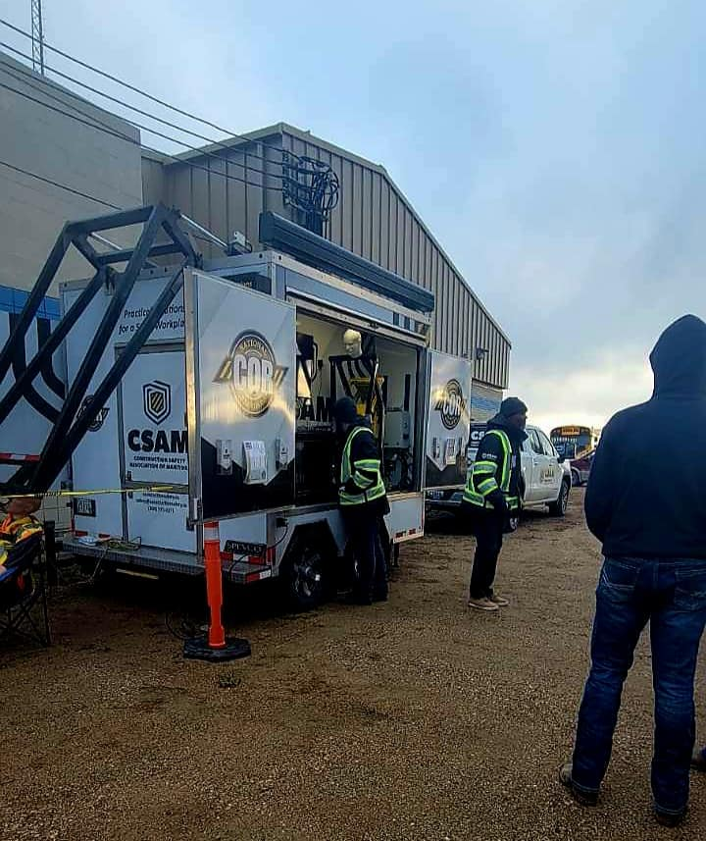
- Mental Health
  - Students talking to the division social worker
  - Staff talking with students about issues.

School Highlights
Safe Workers Presentations
Parent Teacher Interviews in November
Parent- teacher interviews in March
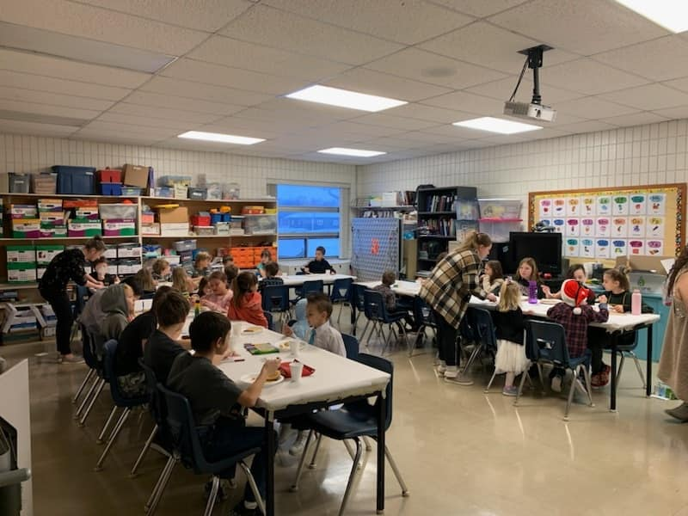
Spirit Weeks
Orange Shirt Day
Pink Shirt Day
100 Day
Remembrance Day Service
Christmas Concert
Terry Fox Walk
Breakfast Program
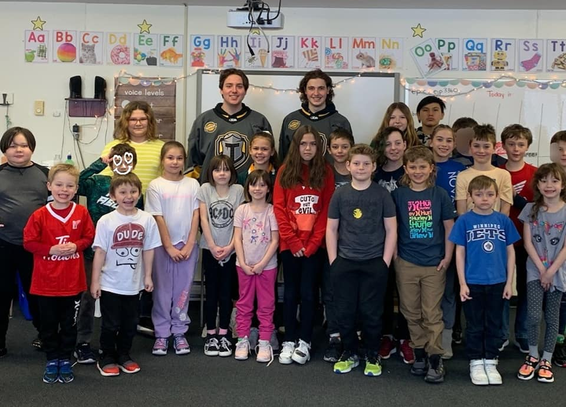
David Robertson presentation
Christmas Breakfast
I Love to Read activities
K- 12 Tubing trip to Valley View Bible Camp

Folk Dance Presentation from Ian at the Cultural Wheel
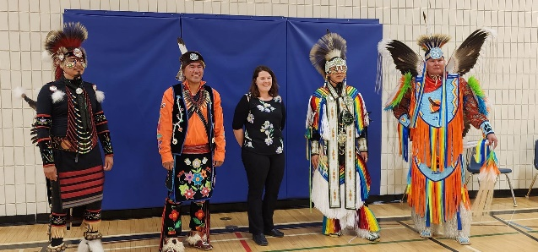
Introduction to Pow Wow presentation
MADD presentations for grades 7-12
Grade 11/12 ACC and BU tours
Grade 9-12 Trip to the Human Rights Museum
K-2 Field trip to Brandon University Mini- U Camp
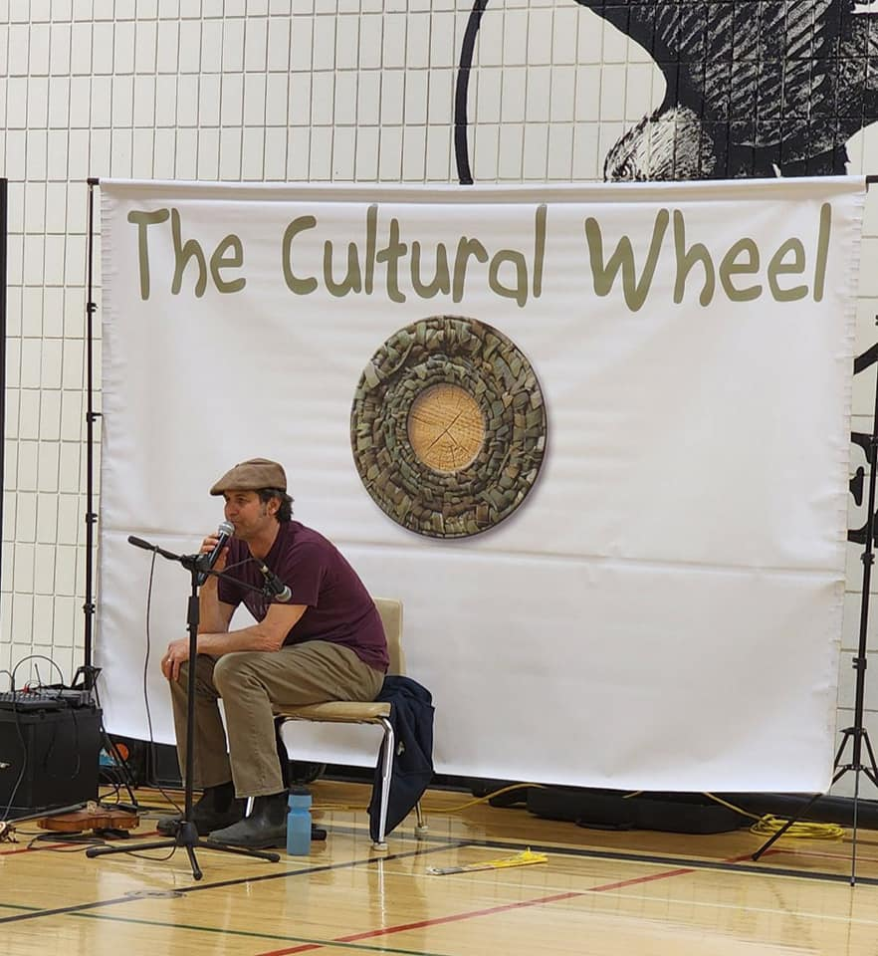
K-6 Field trip to Splash Island
Grade 3-6 Field Trip to the Winnipeg Zoo
Grade 3-6 Swimming lessons at McCreary Pool
Grade 7-8 Field Trip to Brandon University Mini- U camps
K-8 Spring Concert
Graduation Ceremony
K-6 Fields Day
Awards Day
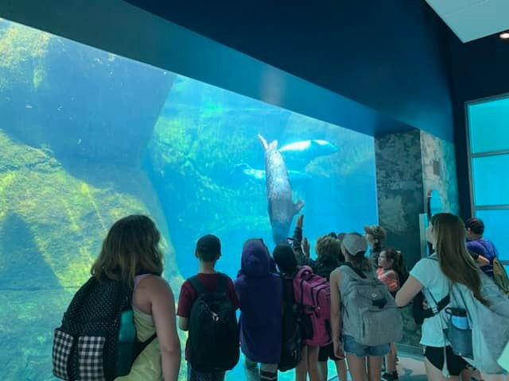
Athletics
Athletics returned to the normal routine this year.
Cross-country
5/6 female division – Natalie Henton 2nd

7/8 female division – Emma Tait 1st, Riley Ray 3rd

Soccer
Jr High – Mixed team placed 2nd
Volleyball
Jr Boys – 4th place @ divisionals

Jr Girls – 2nd place @ divisionals

Sr boys – 2nd place @ zones, ranked 8th in province going into provincial qualifier, lost by 2 points in the final set to Gilbert Plains who qualified for provincials.

Sr girls – 3rd place @ divisionals
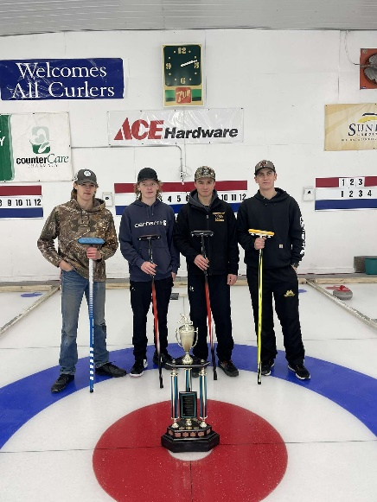
Basketball
Jr girls – 1st place @ divisionals

Jr Boys – 4th place @ divisionals

Curling
Jr Girls – 1st place

Sr Boys – 1st divisionals, 3rd @ zones

Badminton
Jr. Badminton

Kaytee - 2nd in Grade 7 Girls singles
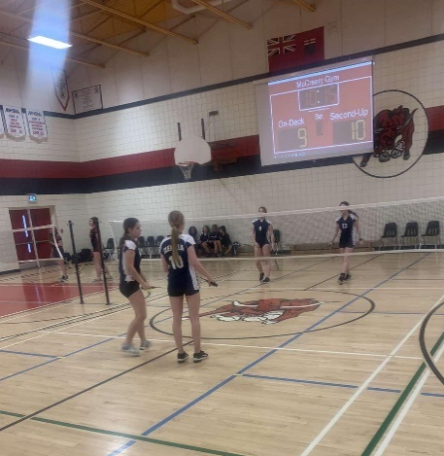
Riley - 2nd in Grade 8 Girls singles

Mylee and Emma - 1st in Grade 8 Girls doubles
Paisley and Leah - 2nd in Grade 8 Girls doubles

Tryp and Jax - 1st in Grade 8 Boys doubles

Sr. Badminton

Morgan – JV Girls Singles, 3rd south sectionals, 2nd zones, qualified for provincials

Track and Field
Matthew – 1st in Javelin, 3rd in discus @ zones, 14th in javelin @ provincials

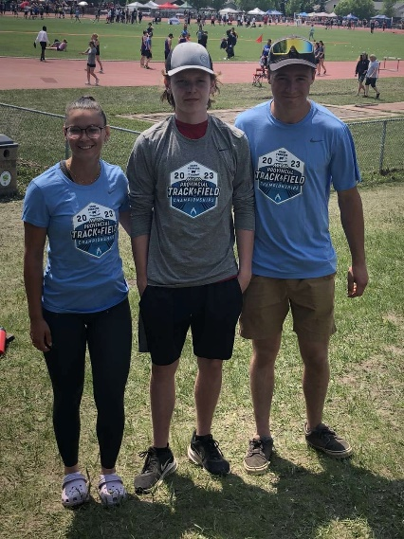
Mitch – 1st in triple jump, 2nd long jump @ zones qualified for provincials

Turtle Derby
Grade 5/6 May 29
Grade 7/8 June 1
Slo-Pitch
4 schools competed, fun had by all

Graduation
Class of 2023
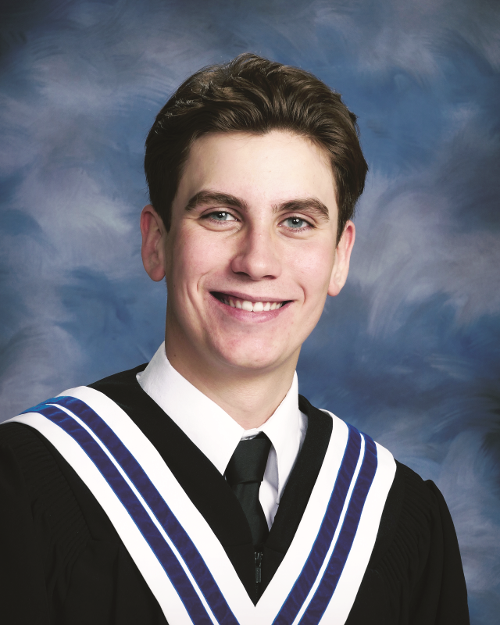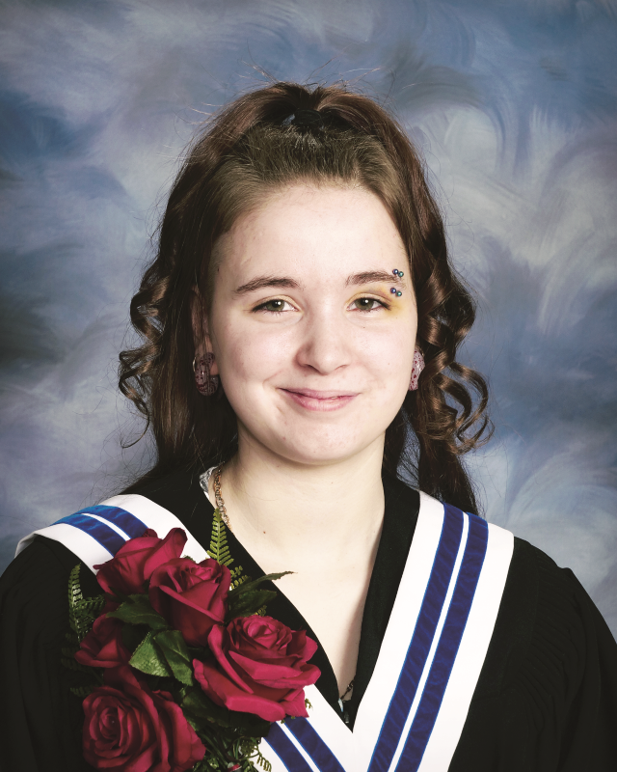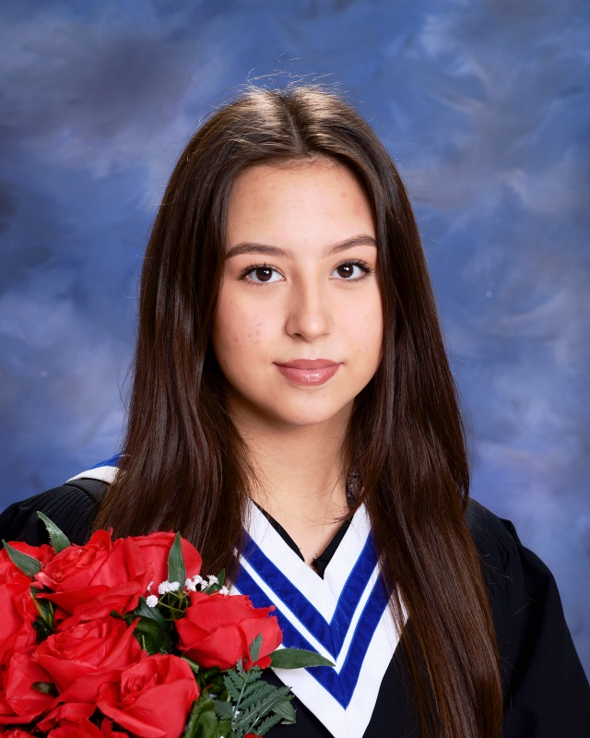
Gavin Dayholos Megan Juskowiak Hailey Schachner
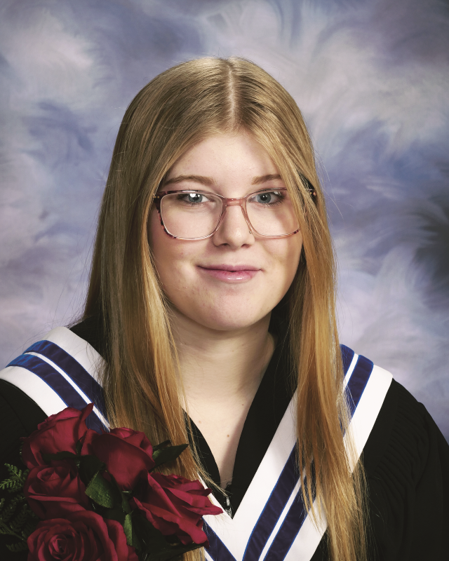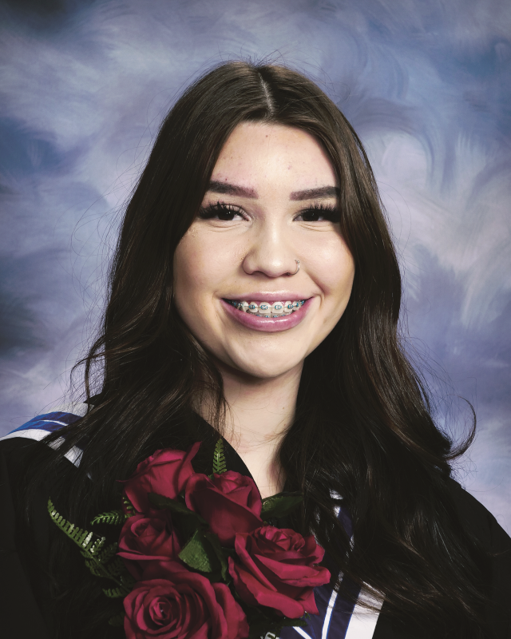
Grace Smith Honor Starr
Graduation Awards
Top Academic Achievement
Essential Math 40S- Gavin Dayholos
Psychology 40S– Grace Smith
Biology 40S- Grace Smith
Global Issues 40S- Grace Smith
Transactional English 40S- Megan Juskowiak
Visual Arts 40S- Megan Juskowiak
Applied Woodworking Technology 40S- Hailey Schachner
Electrical 40S- Gavin Dayholos
Parent Council Awards for the top three achieving students presented by Trena Mitchler
- Gavin Dayholos
- Grace Smith
- Megan Juskowiak
Stride Credit Union Award presented by Michelle Gilmore- Gavin Dayholos
Lisa Flatt Award presented by Mr. Smith- Gavin Dayholos
Governor General Award presented by Amber Petrowski- Gavin Dayholos
Valedictorian- Gavin Dayholos
Departures
We would like to send our well wishes to Mr. Lowry who will be leaving us this year. We thank Mr. Lowry for his hard work and dedication to Glenella School. We wish him the best in his future endeavors.

Principal’s Final Thoughts
This year has been both challenging and rewarding. It is amazing to watch the students’ progress in their education from September to June. The return to normal for our school ceremonies and celebrations added excitement back into the building. Thank you to all the parents, family members, and community members that took part in the school activities to support our students. Congratulations to all the students for their hard work! Congratulations to our graduates we wish you all the best in your future endeavors. We hope everyone has a safe and relaxing summer vacation, and look forward to seeing everyone back in the fall on September 6, 2023.

